****

Chaitanya Malik – NewYug

F-5, Mansukh Apt, B. B. Borkar Rd, Alto Porvorim Goa 403521

**ON**

**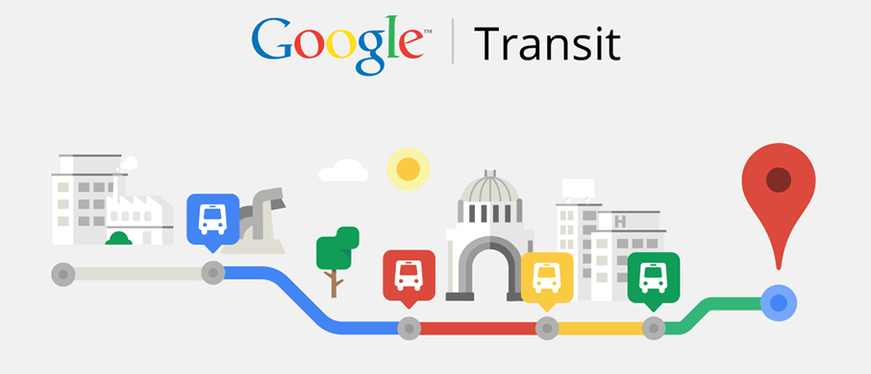**

The project makes innovative use of technology and the power of internet to make accurate travel information available to tourists as well as locals. Goa will be able to develop a sustainable tourism industry by enhancing visitor experience by making information readily available.

Goa on Google

Bringing information to fingertips

Contents

[Executive Summary 2](#_Toc461687176)

[Existing problem 2](#_Toc461687177)

[The solution 2](#_Toc461687178)

[Our offering 2](#_Toc461687179)

[The benefit 2](#_Toc461687180)

[Technical solution 3](#_Toc461687181)

[Google support 3](#_Toc461687182)

[Our offering 3](#_Toc461687183)

[Data entry 4](#_Toc461687184)

[Passenger Experience 5](#_Toc461687185)

[Financials 6](#_Toc461687186)

[Engagement with GTDC 6](#_Toc461687187)

[Role of NewYug 6](#_Toc461687188)

[Role of GTDC 6](#_Toc461687189)

[Financials 6](#_Toc461687190)

[Additional services 7](#_Toc461687191)

[The ‘Happenings in Goa’ Calendar 7](#_Toc461687192)

[The Goa Map 7](#_Toc461687193)

[Taxis on Google Maps 7](#_Toc461687194)

[Summary 7](#_Toc461687195)

# Executive Summary

## Existing problem

Goa is witnessing rampant rise in the usage of personal vehicles by locals as well as tourists. This is taking a major toll on the state's infrastructure, peacefulness and environment. Most people prefer personal vehicles due to lack of awareness of public transport options to get to their destination.

## The solution

Goa's roads and waterways have a strong public transport operated by the Govt. and private operators. The convenience of having the time-table of all public transport services in Goa available on the internet, will translate into people being able to plan their commute in advance and avoid the hassles of using personal vehicles.

## Our offering

We offer on online software that allows transit agencies to publish their routes, stops and timetables to Google Maps. Once the data is published, tourists as well as residents will be able to access travel information without the need of any new app on their phones.

## The benefit

Tourists visiting the state for a limited period will be able to plan their visit in advance long before their visit. Tourists will be able to travel all over Goa without using personal vehicles. Goa will see sustainable tourism development without an additional burden on infrastructure.

# Technical solution

## Google support

Google allows the user to obtain driving, walking and public transit directions between any two locations in the world. The public transit options are available on Google Maps only if the transport providers upload their routes, stops, trip timings to Google. The process of providing the timetables to Google is cumbersome. The data needs to be provided in Google's GTFS format. The entire data can run into thousands of lines of text files. Most importantly, the geo-location of stops has to be accurately provided as a latitude and longitude.

TARA



Provide Fleet Details

GTFS data

Travel options

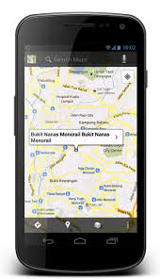

Google Maps on mobile

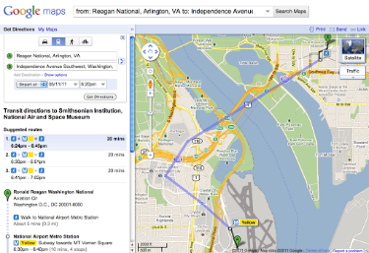

Google Maps on website

## Our offering

The Transit Agency Route Administrator (TARA) simplifies the process of generating the data. It provides a simple visual tool for feeding time-table details of a transit agency.

* The stops can be accurately marked on a map.
* It allows two stops on opposites sides of the road to be linked to each other as peer-stops.
* Each route operated by the agency can be marked on the map by choosing stops that have been previously marked.
* Onward and Return trips on the route can be added by specifying start times of the trips.
* The timings at intermediate stops along the route can be automatically computed by the tool.
* The tool allows offline creation of time-tables in Microsoft Excel.
* The tool generates a passenger-friendly timetable that can be printed and pasted at different locations of the city.
* It can generate the GTFS file that is accepted by Google in its prescribed format.

## Data entry

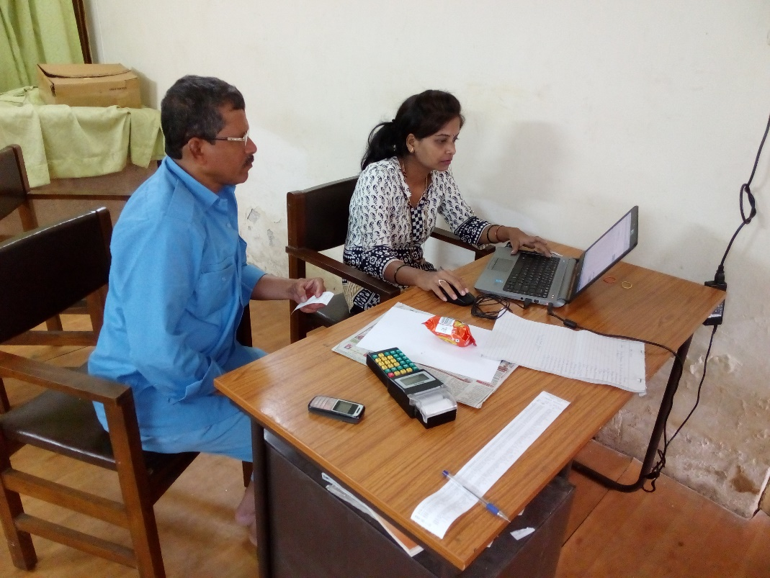

* Data entry is performed with the assistance of a driver.
* The driver guides the operator in identifying the precise location of bus stops on a map.

# Passenger Experience

A passenger can search for travel options between any two points on a Google Maps application. The results provide step-by-step directions including different modes such as Walking, Ferries, and Buses.

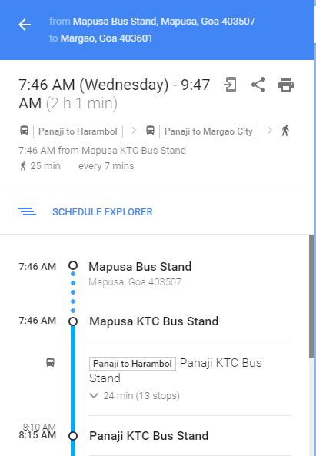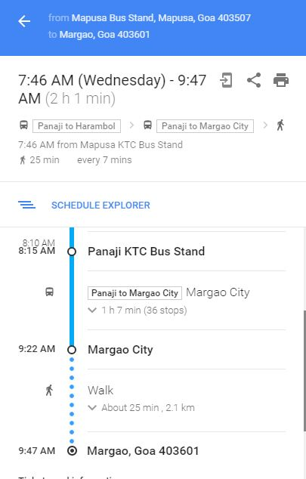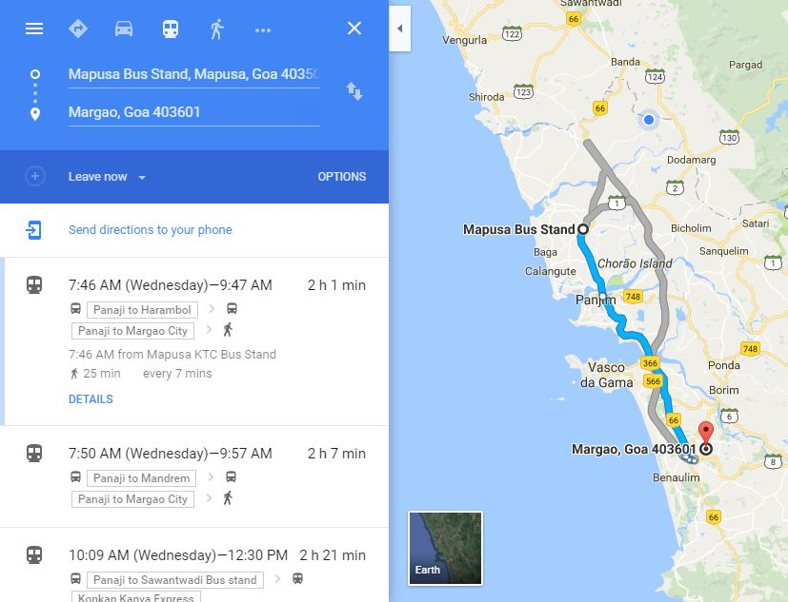

# Financials

* The subscription to the TARA service is based on an annual fee which depends on the approximate number of routes.
* An agency operating 250 routes will be charged a maximum fee of **Rs. 5 Lakhs for the first year**.
* The subscription includes the following:
  + Managing communication with Google for on-boarding the data
  + Training the staff of the agency
  + Automated data entry from existing digital sources held by the agency
  + Dedicated Relationship Manager to resolve queries of the agency
* The annual fee for subsequent years would be half the fee of the first year provided there is no significant increase in the number of routes.

# Engagement with GTDC

Data entry by Kadamba Transport Corporation is in progress. The routes and stops used by Kadamba are similar to that used by private operators. But there are some routes which are not serviced by KTCL and are serviced by private operators too. It will be possible for us to reuse the data that is currently available with us with a lot of new addition.

In Phase 1, GTDC will upload only the timetables of routes that are shared by Kadamba and Private operators.

In Phase 2, GTDC will upload additional routes and stops.

## Role of NewYug

NewYug will provide training to about 5 employees of GTDC to use the software. This training will be conducted over a period of three days.

## Role of GTDC

GTDC shall have to obtain the details of routes not serviced by KTCL to initiate the creation of Stops & Routes. The GTDC will then have to engage with the Directorate of Transport so as to get the Trip timetables of the private operators which will be then fed into the database system.

## Financials

|  |  |
| --- | --- |
| Estimated number of routes | 500 |
| Annual subscription for 1st year | Rs 5 lakhs |
| Annual subscription for 2nd year onwards | Rs 2.5 lakhs |
| Estimated project duration | 3 months |
| Advance payment at start of project | 10% |
| Payment upon completion of Phase 1 | 50% |
| Payment upon completion of Phase 2 | 100% |

# Additional services

## The ‘Happenings in Goa’ Calendar

**[http://bit.do/ingoa](http://bit.do/ingoa" \t "_blank)**

We at Goa IT Professionals will provide a Google Calendar & its back-end to Department of Tourism. **Google Calendar** is a time-management [web](https://en.wikipedia.org/wiki/Web_application" \o "Web application) and [mobile application](https://en.wikipedia.org/wiki/Mobile_app" \o "Mobile app) created by [Google](https://en.wikipedia.org/wiki/Google" \o "Google). Google Calendar is integrated with services like Gmail, iGoogle & Google Desktop. Rather than creating multiple apps Google Calendar is the best web based versatile application for keeping a track of happenings around.

## The Goa Map

A customized online Google map can be created with all places of interest prominently displayed. An example is the tourist map of Rome, Italy available at:

<https://www.google.com/maps/d/u/0/viewer?mid=1qnaRsom_95i4HbpclleVxXh6DTw>

## Taxis on Google Maps

The taxi services run by GTDC and private individuals if brought under a single banner can be hosted on Google Maps through our software similar to Ola & Uber cabs has hosted its service. Customers can be provided with an approximate fare when they query for a destination.

# Summary

This project will place Goa among the few places in India that provide public transport options to citizens at their fingertips. With our capital Panaji being included in the smart city project, this initiative of making Goa digitally equipped and smarter will play a big role. Any agency that subscribes to this service should expect increased revenue from passengers as citizens will begin to turn to public transport. The city/state will witness lesser traffic and cleaner air. Reduced fuel consumption will be a positive side effect of this project.